Level 1:

Enter *<script>alert(“hello world”)</script>* into the input

Level 2:

Just insert an onclick function into the “Share status!” button, then when you click it, the alert will show up

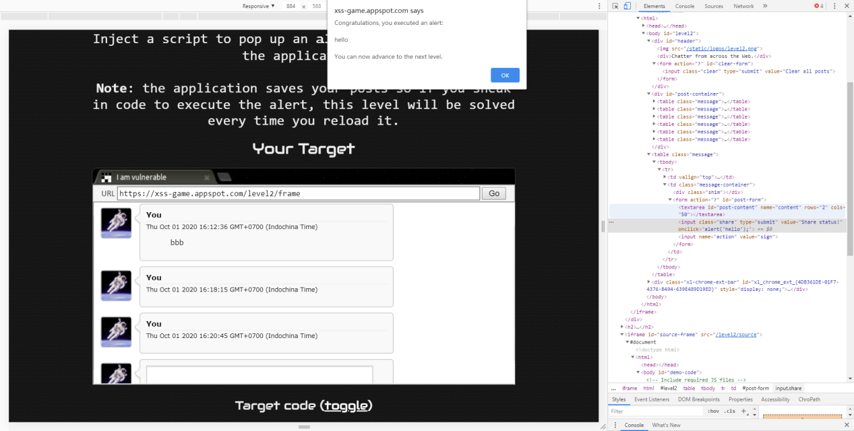

Level 3:

The url is as shown. The bug is that it miss a parseInt() function when choosing the picture, so whatever you put in, it is not checked properly.

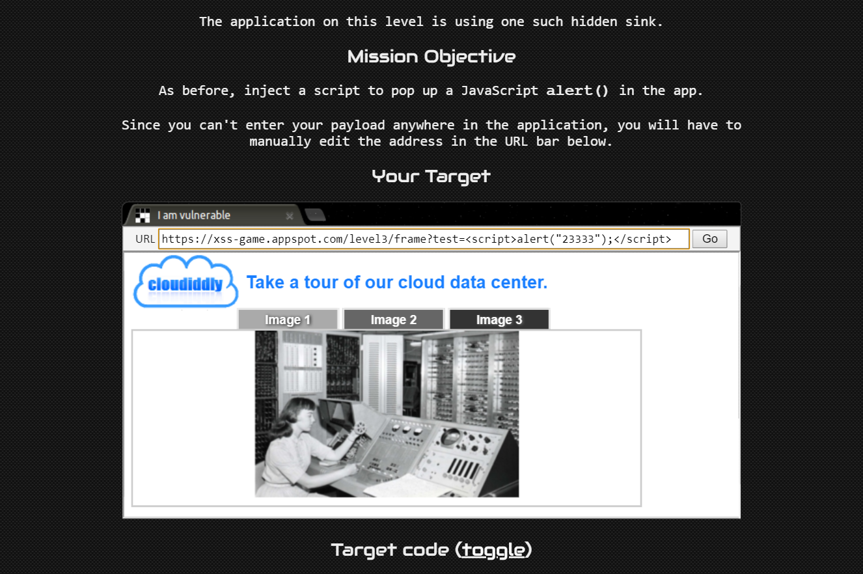

https://xss-game.appspot.com/level3/frame?#3.jpg' onload="alert('2333')" />//

Level 4

Put *10');alert('666* into the input box.

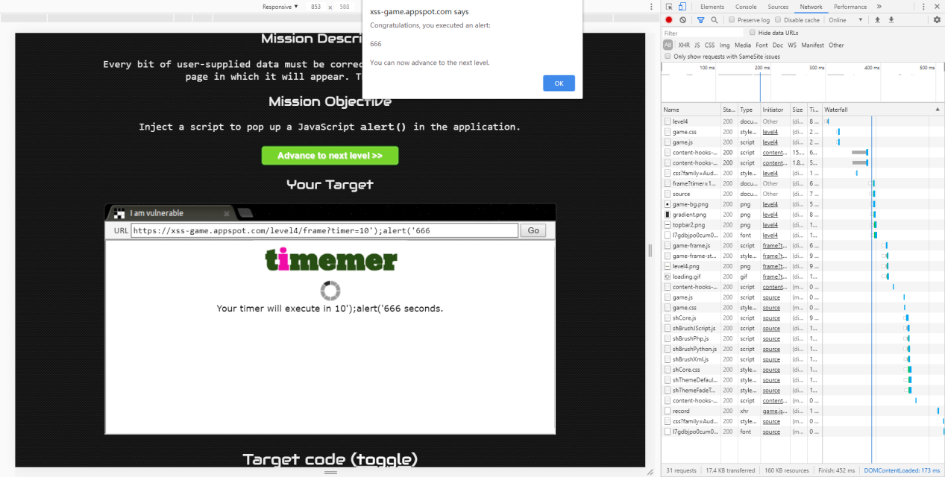

Level 5

To insert a href directing to an *alert(‘666’)* function



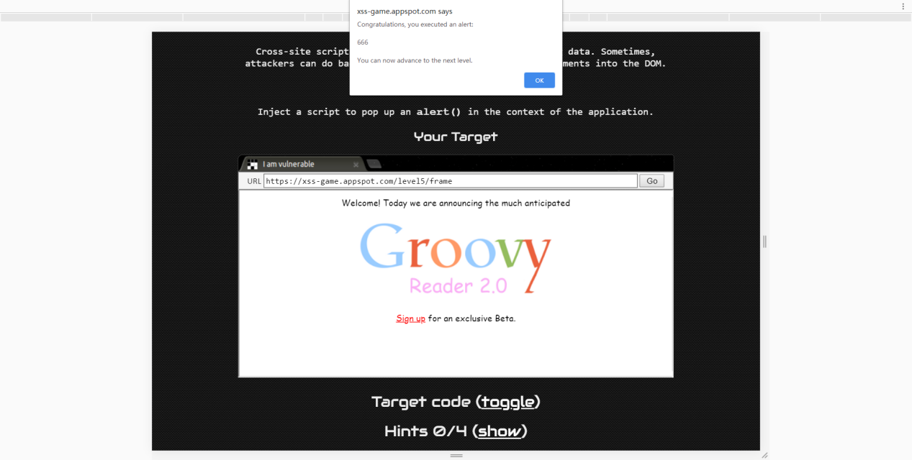

Level 6

Except the normal sulution, there is still a trick: use the bug of the quiz website itself. The url is as follows.

